Paper Title

Aname Asurname^{a,*}, Bname Bsurname^{b} and Cname Csurnameª
ªSchool, University, City, Country
^{b}School, University, City, Country

Abstract

The abstract is to be in fully-justified italicized text as it is here, below the author information. Use the word “Abstract” as the title, in 12-point Times New Roman, boldface type, centered relative to the column, initially capitalized. The abstract is to be in 11-point, single-spaced type, and the length may be up to 300 words. All manuscripts must be in English. The length of the manuscript must be at least 3 pages, excluding authors’ biographies.

Keywords: Enter keywords separated by commas. The number of keywords is between 3 to 5.

1. Introduction

Please follow the steps outlined below when submitting your final draft to JASPE. These guidelines include complete descriptions of the fonts, spacing, and related information for producing your manuscript

2. Formatting your paper

All printed material, including text, illustrations, and charts, must be kept within the parameters of the A4-sized pages with a top margin of 3.0 cm, bottom, left and right margins of 2.5 cm. Please do not write or print outside of the column parameters.

3. Main title

The main title (on the first page) should be centered, and in Times New Roman 14-point, boldface type. Capitalize the first letter of nouns, pronouns, verbs, adjectives, and adverbs; do not capitalize articles, coordinate conjunctions, or prepositions (unless the title begins with such a word). Please initially capitalize only the first word in other titles, including section titles and first, second, and third-order headings (for example, “Titles and headings” — as in these guidelines). Leave two blank lines after the title.

4. Author name(s) and affiliation(s)

Author names and affiliations are centered beneath the title and printed in Times New Roman 12-point, non-boldface type. Affiliations are centered below each author name, italicized, not bold. Contact details of the corresponding author are placed at the footer of the first page.

5. Type-style and fonts

Wherever Times New Roman is specified, Times Roman or Times may be used. If neither is available on your word processor, please use the font closest in appearance to Times New Roman that you have access to. Please avoid using bit-mapped fonts if possible. True-Type 1 fonts are preferred.

6. Main text

Type your main text in 11-point Times New Roman, single-spaced with 13-point interline spacing. Do not use double-spacing. Be sure your text is fully justified—that is, flush left and flush right. Please do not place any additional blank lines between paragraphs. Use standard abbreviations, and define them in full in the first instance unless they are standard measurement units. Avoid any use of abbreviations in the article title and abstract.
Figure and table captions should be 11-point Times New Roman. Initially, capitalize only the first word of each figure caption and table title. Figures and tables must be numbered separately. Figure captions are to be centered below the figures, such as shown in Figure 1. Figures should be high quality (at least 600 dpi for gray scale and 300 dpi for colour, at the correct size). Table titles are to be centered above the tables, such as in Table 1. Tables caption should present new information rather than duplicating what is in the text.

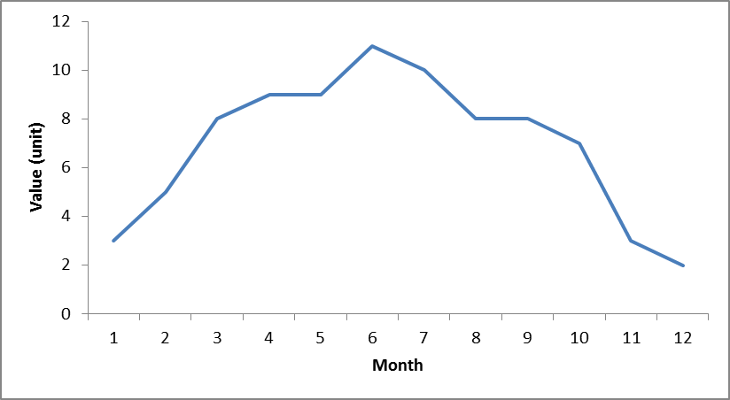
Figure 1. A monthly pattern for xxx.

Table 1. Font sizes for a different section of the manuscript

Section | Font Size
Main title | 14
Section title | 13
Content | 11
Figure caption | 11
Table title | 11
Reference | 10

Number equations consecutively with equation numbers in parentheses flush with the right margin, as in (1).

$\int{ f(r,t)} \text{dr} \text{dt}=r^{2}− (2μ_{0})$ (1)

7. First-order headings

For example, “1. Introduction” should be Times New Roman 13-point boldface, initially capitalized, flush left, with one blank line before, and one blank line after. Use a period (“.”) after the heading number, not a colon. Your main text should be compiled for the research paper in the following order: introduction, materials and methods, results and discussion, and conclusion. For the review paper, the manuscript can omit the experimental section, results and discussion and acknowledgement.

7.1. Second-order headings

As in this heading, they should be Times New Roman 11-point boldface, initially capitalized, flush left, with one blank line before and one after.

7.1.1. Third-order headings

Third-order headings, as in this paragraph, are discouraged. However, if you must use them, use 11-point Times New Roman, boldface, initially capitalized, flush left, with one blank line before and one after.

8. Footnotes

Use footnotes sparingly (or not at all!) and place them at the bottom of the column on the page on which they are referenced. Use Times New Roman 9-point type, single-spaced with 10-point interlining spacing. To help your readers, avoid using footnotes altogether and include necessary peripheral observations in the text (within parentheses, if you prefer, as in this sentence).

Acknowledgements

These should be brief and placed at the end of the text before the references. Please acknowledge sources of financial and material support and those who have contributed intellectually, with their consent.

References

According to the APA standard form, the references are written with the digital object identifier (DOI) as a URL. List and number all bibliographical references in 10-point Times New Roman, single-spaced at the end of your paper. When referenced in the text, enclose the citation number in square brackets, for example [1]. Where appropriate, include the name(s) of editors of referenced books. The guideline and the examples of references are as given as follows:

[1] Surname1, F., & Surname2, S. (Year). Title of the article, Title of Journal, Volume number (Issue number), page range. DOI of the journal article
[2] Surname1, F., & Surname2, S. (Year). Title of the article, In Title of Conference, page range. DOI of the conference article
[3] Surname3, T. (Year). Title of book, Publishing House. DOI of the book article
[4] Kojima, Y., Usuki, A., Kawasumi, M., Okada, A., Fukushima, Y., Kurauchi, T., & Kamigaito, O. (1993). Mechanical properties of nylon 6-clay hybrid. Journal of Materials Research, 8(5), 1185-1189. https://doi.org/10.1557/JMR.1993.1185
[5] Ma, H., & Simon, D. (2010, July). Biogeography-based optimization with blended migration for constrained optimization problems. In Proceedings of the 12th annual conference on Genetic and evolutionary computation, 417-418. https://doi.org/10.1145/1830483.1830561
[6] Nelson, M., & Gailly, J. L. (1995). The data compression book 2nd edition. M & T Books, New York, NY. https://doi.org/10.1177/027046769601600426

Do not use the phrases "et al." and "ibid." in the reference section. Instead, the names of all authors in a reference must be listed.

